Week 1 Report — Financial Returns, Probability and Data Handling
Project: AI/ML-Augmented Black–Scholes Framework for Option Pricing and Market-Risk Analysis
Work plan reference: §11.1 · Mathematical reference: §3.1
Primary text: Carol Alexander, Market Risk Analysis Volume I: Quantitative Methods in Finance
Asset: NIFTY 50 (^NSEI) · Period: 2 January 2015 – 31 December 2024
Submitted by: Sanskar
Contents
1. Objective and scope
2. Data
3. Methodology
4. Result 1 — Numerical verification that r ≈ R
5. Result 2 — Time-additivity of log returns
6. Result 3 — Descriptive statistics
7. Result 4 — The σ²/2 correction term observed in data
8. Result 5 — Normality of daily log returns
9. Result 6 — Tail event frequencies
10. Figures
11. Discussion — milestone questions
12. Conclusions
13. Reproducibility
14. Work planned for Week 2

1. Objective and scope
Week 1 covers the statistical description of financial returns, which forms the empirical foundation for the geometric Brownian motion model in Week 2 and the Black–Scholes framework in Week 3.
The seven computational tasks specified in §11.1 were completed in full:
# | Task (§11.1) | Report section
1 | Import a sample asset-price time series | 2
2 | Compute simple returns | 3
3 | Compute log returns | 3
4 | Calculate mean, variance, skewness and kurtosis | 6
5 | Plot the price series | 10
6 | Plot the return series | 10
7 | Plot a return histogram | 10
The stated mathematical objective was to understand why log returns are useful and to verify numerically that r ≈ R for sufficiently small returns. This is addressed in Section 4.

2. Data
Daily closing levels of the NIFTY 50 index were obtained from Yahoo Finance under the ticker ^NSEI, adjusted for corporate actions.
Property | Value
Source | Yahoo Finance via yfinance, auto_adjust=True
Ticker | ^NSEI (NIFTY 50)
Period | 2 January 2015 to 31 December 2024
Observations | 2,459 daily closes
Return observations | 2,458
Minimum index level | 6,970.60
Maximum index level | 26,216.05
Four validation checks were applied before any analysis: no missing values, strictly positive prices (required for logarithms to be defined), a monotonically increasing date index, and no duplicate dates. All four passed.

3. Methodology
Two definitions of return were computed for each trading day.
Simple return. The proportional change in value,
$$R_{t}=\frac{S_{t}−S_{t−1}}{S_{t−1}}=\frac{S_{t}}{S_{t−1}}−1$$
Log return. The continuously compounded return,
$$r_{t}=\text{ln}​\left(\frac{S_{t}}{S_{t−1}}\right)=\text{ln}S_{t}−\text{ln}S_{t−1}$$
The two are connected by the exact identity $r_{t}=\text{ln}(1+R_{t})$, which was verified computationally to machine precision rather than assumed.
Observed ranges over the sample:
 | Minimum | Maximum
Simple return $R_{t}$ | −0.129805 | 0.087632
Log return $r_{t}$ | −0.139038 | 0.084003
The log return is more negative on the worst day and less positive on the best. This asymmetry follows from the concavity of the logarithm and is the reason $r_{t}$ is unbounded below while $R_{t}∈[−1,∞)$ — a point returned to in Section 11.
All computation used Python 3.12 with NumPy, pandas, SciPy and Matplotlib, per §4.1. No machine learning libraries were used at this stage.

4. Result 1 — Numerical verification that r ≈ R
Expanding the exact identity as a Taylor series about $R=0$,
$$r=\text{ln}(1+R)=R−\frac{R^{2}}{2}+\frac{R^{3}}{3}−⋯$$
so the difference between the two definitions is second order:
$$r−R≈−\frac{R^{2}}{2}$$
The claim “$r_{t}≈R_{t}$ for sufficiently small returns” was therefore tested in two ways: by magnitude, and by scaling behaviour.

4.1 Magnitude of the difference
Statistic | Value
Mean absolute difference | 5.542 × 10⁻⁵
Maximum absolute difference | 9.233 × 10⁻³
Return on which the maximum occurred | −0.1298

4.2 Accuracy by return size
|R| band | n | Mean |r − R| | Mean relative error
0.000 – 0.005 | 1,175 | 0.000004 | 0.115 %
0.005 – 0.010 | 735 | 0.000027 | 0.363 %
0.010 – 0.020 | 435 | 0.000096 | 0.678 %
0.020 – 0.050 | 102 | 0.000377 | 1.333 %
0.050 – 1.000 | 11 | 0.002877 | 3.659 %
The approximation is accurate to roughly one part in a thousand for the small daily moves that constitute the bulk of the sample, and degrades systematically as the return grows — which is exactly what a second-order error term predicts.

4.3 Scaling test
To confirm the error is genuinely $O(R^{2})$ rather than merely small, the regression
$$\text{ln}|r−R|=a+b\text{ln}|R|$$
was fitted. Theory requires $b=2$ and $a=\text{ln}(1/2)=−0.6931$.
Parameter | Fitted | Theoretical | Agreement
Slope $b$ | 2.0000 ± 0.0001 | 2 | 4 decimal places
Intercept $a$ | −0.6932 | −0.6931 | 4 decimal places
$R^{2}$ | 1.0000 | — | —
The Taylor expansion is confirmed to four decimal places on ten years of real market data. This converts the informal statement “for sufficiently small returns” into a precise one: halving the return size quarters the approximation error.

5. Result 2 — Time-additivity of log returns
Log returns are additive across time,
$$\text{ln}​\left(\frac{S_{t_{N}}}{S_{t_{0}}}\right)=\sum_{i=1}^{N}{\text{ln}}​\left(\frac{S_{t_{i}}}{S_{t_{i−1}}}\right)$$
whereas simple returns compound multiplicatively,
$$1+R_{0→N}=\prod_{i=1}^{N}{(}1+R_{i})$$
Both were tested over the full ten-year sample.
Quantity | Value | Status
$\text{ln}(S_{T}/S_{0})$ | 1.03545333 | —
Sum of daily $r_{t}$ | 1.03545333 | Agrees
Difference | 4.44 × 10⁻¹⁶ | Machine precision
$S_{T}/S_{0}−1$ (true total return) | 1.81638271 | —
$∏(1+R_{t})−1$ | 1.81638271 | Correct
Sum of daily $R_{t}$ | 1.17167543 | Incorrect
Error from summing simple returns | 0.6447 | —
Summing simple returns understates the true ten-year return by 64.5 percentage points, or more than one third of the realised gain. Summing log returns is exact to machine epsilon.
This is the strongest practical argument for the log-return convention: one definition is exact and costless, the other is wrong by a wide margin.

6. Result 3 — Descriptive statistics
Statistic | Simple return $R_{t}$ | Log return $r_{t}$
Observations | 2,458 | 2,458
Mean | 0.000477 | 0.000421
Variance | 0.000110 | 0.000111
Standard deviation | 0.010478 | 0.010545
Skewness | −1.098792 | −1.407643
Excess kurtosis | 17.677994 | 20.413236
Raw (Pearson) kurtosis | 20.677994 | 23.413236
Minimum | −0.129805 | −0.139038
Maximum | 0.087632 | 0.084003
Mean, annualised | 0.120123 | 0.106157
Volatility, annualised | 0.166334 | 0.167389
Note on kurtosis convention. Two conventions are in circulation and are easily confused. Raw (Pearson) kurtosis equals 3 for a normal distribution; excess kurtosis equals 0. SciPy returns excess kurtosis by default. Both are reported above so that no ambiguity arises.
Three observations:
- The daily mean is near zero — at daily frequency, drift is negligible beside noise.
- Skewness is strongly negative, indicating that large downward moves outweigh large upward ones.
- Excess kurtosis above 20 indicates extremely heavy tails relative to the normal distribution.
The annualised volatility of approximately 16.7 % is the first empirical estimate of the parameter σ that enters the Black–Scholes formula in Week 3.

7. Result 4 — The σ²/2 correction term observed in data
The difference between the mean simple return and the mean log return was compared against half the sample variance.
Quantity | Value
$\overline{R}−\overline{r}$ | 0.00005542
${\hat{σ}}^{2}/2$ | 0.00005559
Relative difference | 0.31 %
Annualised, the gap between the two mean returns is 12.01 % − 10.62 % = 1.40 %, against ${\hat{σ}}^{2}/2×252=1.40 \%$.
Significance. This is the Itô correction term, identified empirically before the model that predicts it has been introduced. In Week 2, applying Itô’s lemma to $f=\text{ln}S$ under geometric Brownian motion
$$\frac{dS_{t}}{S_{t}}=μ dt+σ dW_{t}$$
yields
$$d\text{ln}S_{t}=\left(μ−1/2σ^{2}\right)dt+σ dW_{t}$$
The $−1/2σ^{2}$ term has no counterpart in ordinary calculus and arises because the squared increments of a Wiener process accumulate at order $dt$ rather than $dt^{2}$. It is recovered here to three significant figures from two sample means and one sample variance, with no model assumed. It also explains, quantitatively, why the arithmetic average return exceeds the geometric average return.

8. Result 5 — Normality of daily log returns
The Black–Scholes framework assumes that $\text{ln}(S_{t}/S_{0})$ is normally distributed and $S_{t}$ is lognormal (§1.1). This assumption was tested directly.
Test | Statistic | p-value
Jarque–Bera | 43,304.26 | 0.000
Shapiro–Wilk (first 5,000 obs) | W = 0.878015 | 3.018 × 10⁻⁴⁰
Moment | Observed | Normal
Skewness | −1.4076 | 0
Excess kurtosis | 20.4132 | 0
The Jarque–Bera statistic combines skewness and excess kurtosis as
$$JB=\frac{n}{6}\left(S^{2}+\frac{(K−3)^{2}}{4}\right)∼χ_{2}^{2} \text{ under normality}$$
The 1 % critical value of $χ_{2}^{2}$ is 9.21. The observed statistic exceeds it by a factor of approximately 4,700.
Normality is rejected at the 1 % level, and by an overwhelming margin.

9. Result 6 — Tail event frequencies
Standardised log returns $z_{t}=(r_{t}−\overset{‾}{r})/\hat{σ}$ were compared against the frequencies a normal distribution predicts.
Threshold | Observed | Expected under normality | Ratio
|z| > 2 | 97 | 111.84 | 0.9 ×
|z| > 3 | 29 | 6.64 | 4.4 ×
|z| > 4 | 15 | 0.16 | 96.3 ×
|z| > 5 | 10 | 0.0014 | 7,096 ×
Two features deserve comment.
The 2σ row is below unity. There are fewer two-sigma days than normality predicts. This is not inconsistent with fat tails — it is characteristic of them. Both distributions share the same variance by construction, so the excess mass concentrated in the centre and in the far tails must be drawn from the shoulders, the region between roughly one and two standard deviations. The log-density histogram (Figure 4) shows the same effect visually.
The ratios accelerate. Moving from 2σ to 5σ, the discrepancy grows from 0.9 to over 7,000. Under normality, a five-sigma daily move has probability 5.7 × 10⁻⁷ and would be expected approximately once in 6,900 years. Ten such days occurred within this ten-year sample.
This is the empirical gap that motivates the project’s central research question.

10. Figures
Five figures were produced and saved to figures/.
Figure 1 — Approximation error (w01_approximation_error.png). Left: $|r−R|$ against $|R|$ with the theoretical curve $R^{2}/2$ overlaid. Right: the same on log–log axes, where the fitted slope of 2.000 confirms second-order error.
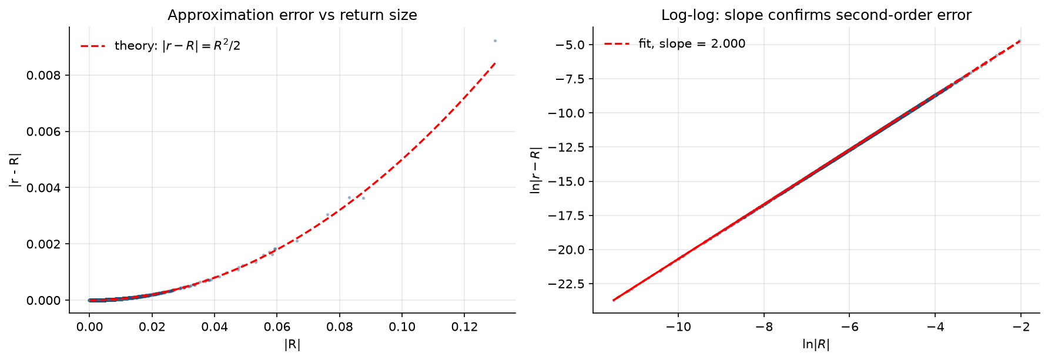
Figure 2 — Price series (w01_price_series.png). NIFTY 50 on linear and logarithmic scales. On the linear panel the fluctuations of 2015–2017 appear negligible beside those of 2024; on the log panel they are comparable. Nothing about market behaviour changed — only the index level did. This is the clearest illustration of why price levels are unsuitable as a direct modelling object.
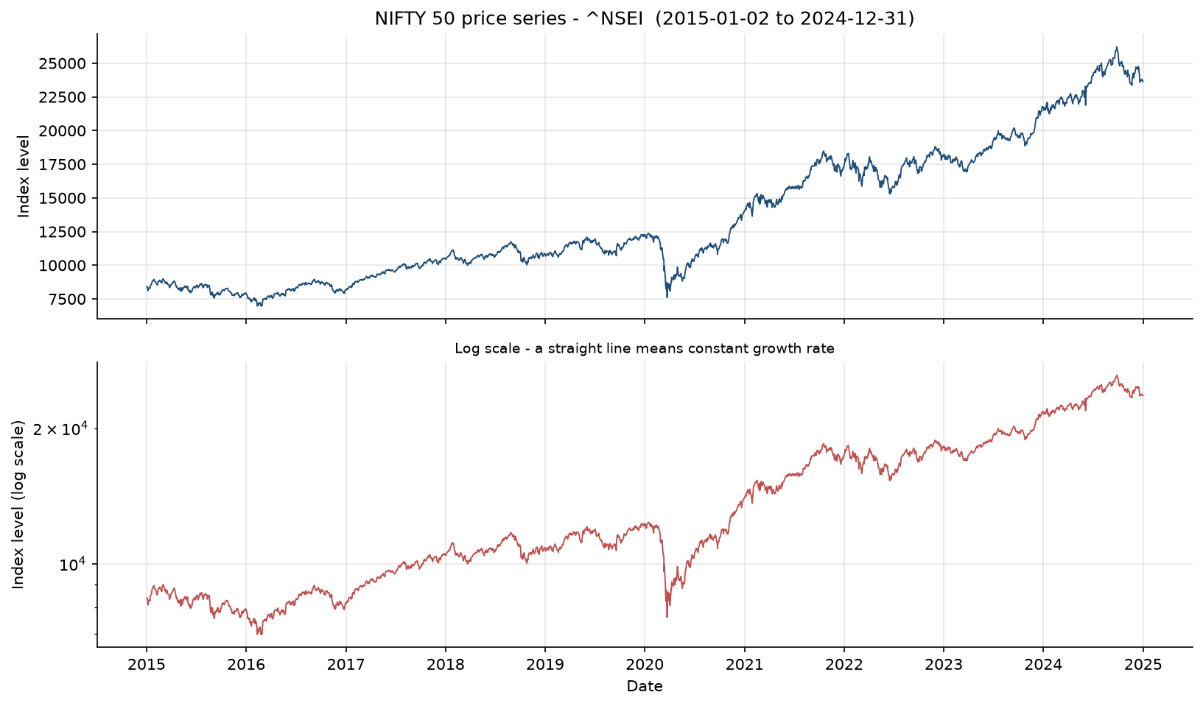
Figure 3 — Return series (w01_return_series.png). Daily simple and log returns. In contrast to the price series, returns oscillate about zero throughout the decade, illustrating approximate stationarity. Volatility clustering is clearly visible: the March 2020 period shows sustained large moves, while 2017 and 2023 are comparatively quiet. Three episodes are identifiable — the August 2015 yuan devaluation, the March 2020 COVID-19 crash (the −12.98 % day), and the June 2024 election result.
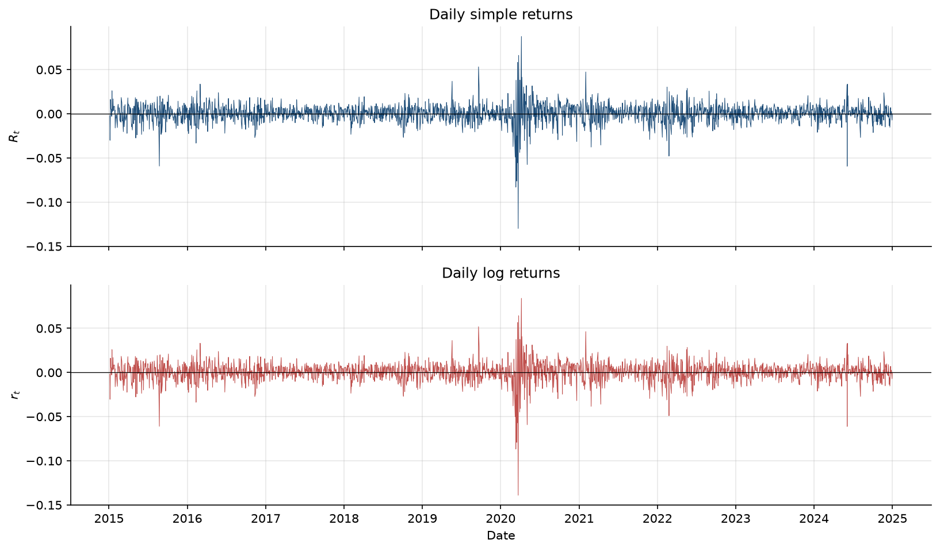
Figure 4 — Return histogram (w01_return_histogram.png). Empirical log-return density against a fitted normal, on linear and logarithmic density scales. The empirical peak reaches approximately 59 against the normal’s 38, while the tails extend far beyond it — the distribution is simultaneously more peaked and more heavily tailed. On the log-density panel the vertical axis spans forty orders of magnitude, and at the worst observed return the empirical density exceeds the fitted normal density by roughly thirty-four orders of magnitude.
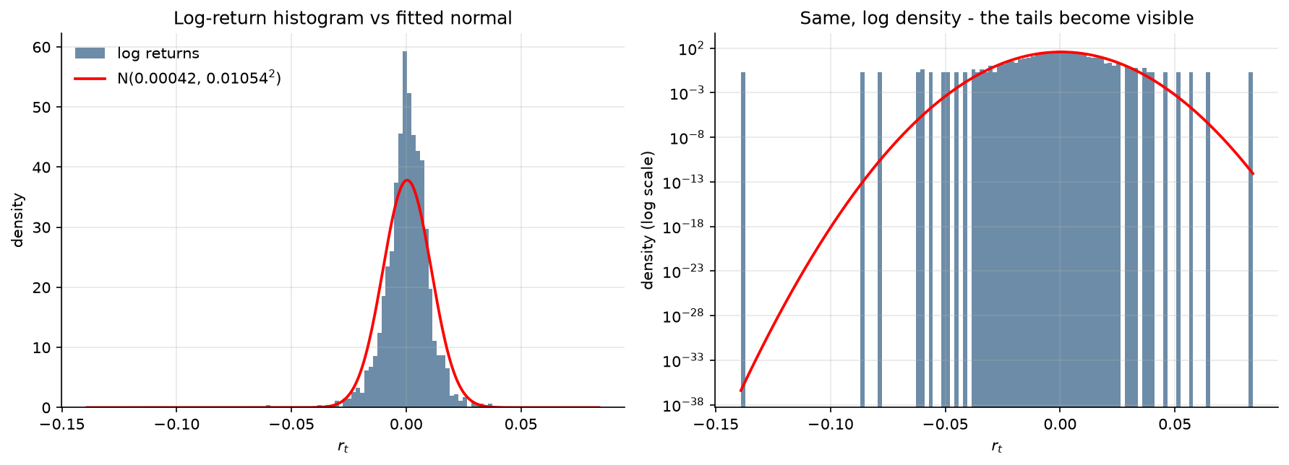
Figure 5 — Normality diagnostics (w01_normality.png). Left: QQ plot against the normal distribution, showing the characteristic S-shape of a fat-tailed distribution. The deviation is markedly larger in the left tail, consistent with the negative skewness. Right: the empirical distribution against a simulated normal sample with identical mean and standard deviation. The simulated sample is confined to roughly ±0.03 while the empirical data extends beyond ±0.13, demonstrating that agreement on the first two moments implies nothing about tail behaviour.
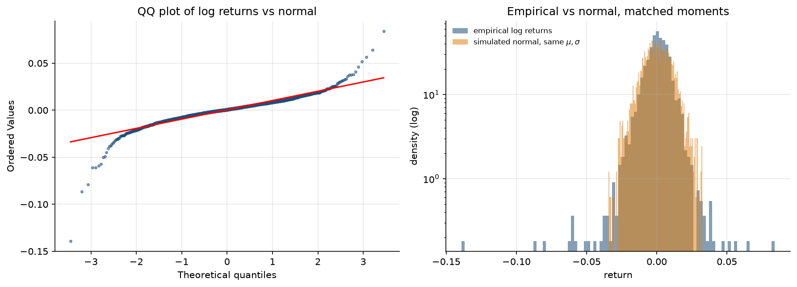

11. Discussion — milestone questions
§11.1 requires the student to be able to explain two things.

11.1 Why are asset prices and asset returns different modelling objects?
Prices are non-stationary; returns are approximately stationary. The price series has no fixed mean or variance to estimate. Over this sample the index ranged from 6,970 to 26,216 with no tendency to revert to any level. Standard statistical procedures do not apply to such a series. Returns, by contrast, oscillate about a stable mean, so their moments can be estimated, tested and modelled — as done throughout this report.
Three further consequences follow:
- Scale invariance. A 200-point move at an index level of 8,000 and the same 200-point move at 26,000 are entirely different events. Expressed as returns, 2.5 % and 0.77 %, the difference is explicit. Figure 2 shows this directly.
- Positivity. Prices cannot be negative, so any additive model of the price level is structurally wrong. Modelling returns and exponentiating enforces $S_{t}>0$ automatically. This is precisely why geometric Brownian motion is geometric rather than arithmetic; Alexander makes the same argument in §I.3.7.3.
- Comparability. Returns are dimensionless and can therefore be compared and aggregated across assets, periods and currencies.

11.2 Why are log returns preferred in continuous-time models?
Reason | Evidence in this report
Time-additive. An $N$-period log return is the sum of the one-period log returns, so a multi-period return is a sum of increments — exactly what a stochastic differential equation describes. Simple returns compound and do not sum. | Section 5: exact to 4.44 × 10⁻¹⁶, against a 64.5-point error for simple returns
Symmetric. A gain of 50 % followed by a loss of 50 % leaves a simple return of −25 %; in log terms +0.405 and −0.693 correctly fail to cancel. Log returns place gains and losses on a common scale. | Section 3: asymmetry of the observed minima and maxima
Unbounded below. $R_{t}∈[−1,∞)$ is asymmetric and cannot be normally distributed. $r_{t}∈(−∞,∞)$ can be. Since geometric Brownian motion assumes $\text{ln}S_{t}$ is normal, the log return is the object the model actually concerns. | Sections 3 and 8
Negligible cost. The two definitions differ at second order, so at daily frequency the choice sacrifices almost nothing in accuracy while securing all of the above. | Section 4: relative error of 0.115 % for typical daily moves

12. Conclusions
- All seven computational tasks required by §11.1 were completed on real market data.
- The relationship $r_{t}≈R_{t}$ was verified not merely in magnitude but in scaling behaviour, with the fitted exponent and constant both matching theory to four decimal places.
- Log returns were shown to be exactly additive over ten years, while summing simple returns produced an error of 64.5 percentage points.
- The daily log returns of the NIFTY 50 are not normally distributed. Skewness is −1.41, excess kurtosis is 20.41, and normality is rejected by Jarque–Bera at a statistic of 43,304 against a 1 % critical value of 9.21.
- Tail events occur far more often than the normal distribution allows, with the discrepancy growing from 0.9× at two standard deviations to 7,096× at five.
- Volatility is visibly non-constant (Figure 3), exhibiting pronounced clustering.
- The Itô correction term σ²/2 was recovered empirically to three significant figures before the model predicting it was introduced.
Relevance to the project. Points 4, 5 and 6 each contradict an assumption on which the Black–Scholes model rests — normality of log returns and constancy of volatility. These violations are measurable in the raw data before any pricing model has been implemented, and they define the gap the project’s central research question asks whether machine learning can close.
Estimated parameters carried forward: annualised volatility 16.7 %, annualised drift 10.6 % (log) or 12.0 % (simple).

13. Reproducibility
Item | Value
Script | week01_returns_analysis.py
Notebook | week01_returns_analysis.ipynb
Random seed | 20260825
Environment | Python 3.12; NumPy, pandas, SciPy, Matplotlib, yfinance
Cached data | data/nifty50_prices.csv
Numerical results | results/w01_summary.csv, results/w01_descriptive_statistics.csv
Figures | figures/w01_*.png (5 files)
The price data is cached on first download, so subsequent runs reproduce identical results independently of network conditions or later data revisions.

14. Work planned for Week 2
Per §11.2: Brownian motion and geometric Brownian motion. Simulation of GBM paths, verification that simulated log returns are normally distributed with mean $(μ−1/2σ^{2})Δt$ and variance $σ^{2}Δt$, and comparison of the simulated distribution against the empirical NIFTY 50 distribution characterised in this report. The σ²/2 term identified in Section 7 will be derived analytically via Itô’s lemma.

